In this section, we will learn what is a Catalan number and also create Java programs to check if the given number is a Catalan number or not. The Catalan number program is frequently asked in Java coding interviews and academics.
There are many interesting problems that can be solved using the Catalan number. Mathematically, the Catalan numbers are defined as,
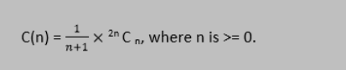

Steps to Find the Catalan Numbers
Step 1: Assign a non-negative integer to the variable n.
Step 2: Find the value of ^{2n}C_{n}, where n is determined in step 1.
Step 3: Divide the value found in step 2 by n+1. The resultant that we get after the division is a Catalan number.
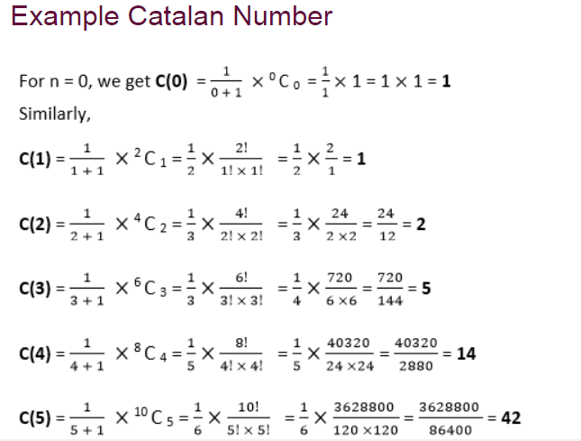
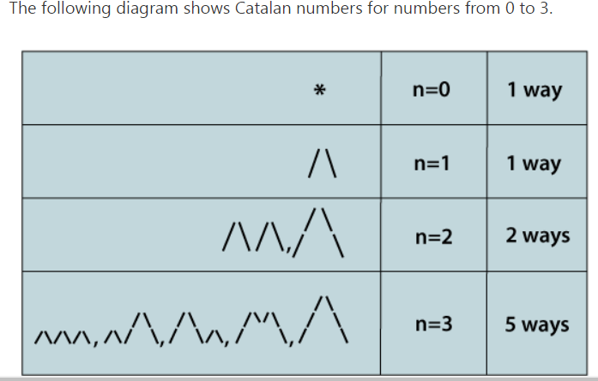

import java.util.Scanner;

public class Catalan_Number {

public static long findFact(int no) {

long res=1;
for(int i =1;i<=no;i++)
res=res*i;
return res;

}
public static long findCatalan(int n)
{
// for no = 0 & 1, the catalan number is 1
if(n<=1)
{
return 1;
}
// Calculating 2n!
long fact=findFact(2*n);
// calculating 2nCn
fact=fact/findFact(n);
fact=fact/findFact(n);
//caculating ((1 / (n + 1))* 2nCn)
fact = fact / (n + 1);
return fact;
}
public static void main(String[] args) {
// TODO Auto-generated method stub

Scanner sc = new Scanner(System.in);
int num=sc.nextInt();
if (num<=0)
System.out.println("0");
else
{
for(int i=0;i<num;i++)
{
long catlanNo=findCatalan(i);
System.out.print(catlanNo+" ");
}
}

}

}
import java.util.Scanner;

public class Recursive_Catalan {
public static long catalan(int n) {
int res = 0;

// Base case
if (n <= 0) {
return 1;
}
for (int i = 0; i < n; i++) {
res += catalan(i) * catalan(n - i - 1);
}
return res;
}
public static void main(String[] args) {
// TODO Auto-generated method stub
Scanner sc = new Scanner(System.in);
int num=sc.nextInt();
if (num<=0)
System.out.println("0");
else
{
for(int i=0;i<num;i++)
{
long catlanNo=catalan(i);
System.out.print(catlanNo+" ");
}
}
}

}

import java.util.ArrayList;
import java.util.HashMap;

public class Example {

public static void main(String[] args) {

int n=10;
ArrayList<Integer> c= new ArrayList<Integer>();
c.add(1);
for(int i=1;i<=n;i++)
{
c.add(catalanfunc(c,i));
}
System.out.println(c);

}

private static Integer catalanfunc(ArrayList<Integer> c, int z) {
// TODO Auto-generated method stub

int cat=0;
for(int i=0;i<z;i++)
{
cat=cat+c.get(i)*c.get(z-i-1);
}

return cat;
}
}

Time o(n2)
Sp-0(n)

https://www.geeksforgeeks.org/applications-of-catalan-numbers/

